**Praktikum Mikroprosesor 2**

Materi : bab 4 – Library Hardware

Waktu pengerjaan 90 menit

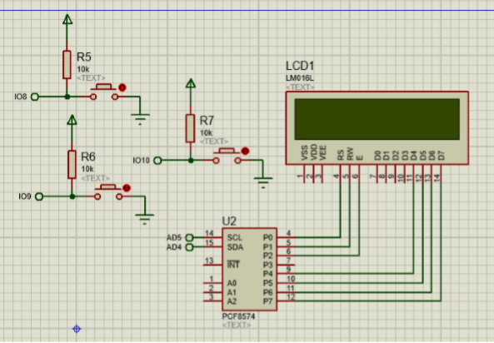Penjelasan : menggunakan LCD 16x2 + i2c, menggunakan 3 button,pin dan rangkaian di harapakan sama seperti gambar!!

1. Buat lah menu awal di LCD seperti ini :

|  |  |  |  |  |  |  |  |  |  |  |  |  |  |  |  |
| --- | --- | --- | --- | --- | --- | --- | --- | --- | --- | --- | --- | --- | --- | --- | --- |
|  | S | E | L | A | M | A | T |  |  |  | M | A | I | N |  |
|  |  |  |  |  |  |  |  |  |  |  |  |  |  |  |  |

setelah button kasih nama aja “but1”.but1 di tekan,maka masuk ke game dengan tampilan seperti ini.

|  |  |  |  |  |  |  |  |  |  |  |  |  |  |  |  |
| --- | --- | --- | --- | --- | --- | --- | --- | --- | --- | --- | --- | --- | --- | --- | --- |
| o | o | o | o | o | o | o | o | o | o | o | o | o | o | o | o |
| Y |  |  |  |  |  |  |  |  |  |  |  |  |  |  |  |

Keterangan :

o = adalah tanah kosong

Y = adalah petani

1. Apabila but1 di tekan,maka petani menanam tanaman di atasnya contohnya seperti ini :

|  |  |  |  |  |  |  |  |  |  |  |  |  |  |  |  |
| --- | --- | --- | --- | --- | --- | --- | --- | --- | --- | --- | --- | --- | --- | --- | --- |
| x | o | o | o | o | o | o | o | o | o | o | o | o | o | o | o |
| Y |  |  |  |  |  |  |  |  |  |  |  |  |  |  |  |

Keterangan :

x = tanah yang sudah di kasih bibit

o = tanah yang masih kosong

Y = petani

1. Setelah 5 detik,maka tanaman akan siap di petik.

Tampilan tanaman yang siap di petik seperti ini :

|  |  |  |  |  |  |  |  |  |  |  |  |  |  |  |  |
| --- | --- | --- | --- | --- | --- | --- | --- | --- | --- | --- | --- | --- | --- | --- | --- |
| V | o | o | o | o | o | o | o | o | o | o | o | o | o | o | o |
| Y |  |  |  |  |  |  |  |  |  |  |  |  |  |  |  |

Keterangan :

V = tanaman yang siap di ambil

Y = petani

O = tanah yang tidak ada tanaman maupun bibit

1. Ketika but1 di tekan,maka petani akan memanen tanaman tersebut.Kemudian tanah kembali seperti awal atau kosong :

|  |  |  |  |  |  |  |  |  |  |  |  |  |  |  |  |
| --- | --- | --- | --- | --- | --- | --- | --- | --- | --- | --- | --- | --- | --- | --- | --- |
| o | o | o | o | o | o | o | o | o | o | o | o | o | o | o | o |
| Y |  |  |  |  |  |  |  |  |  |  |  |  |  |  |  |

Apa bila sudah di panen maka score atau counter bertambah 1

1. Apa bila tanaman siap di petik tidak di ambil selama 3 detik,maka game akan selesai dan tampilanya menjadi seperti ini :

|  |  |  |  |  |  |  |  |  |  |  |  |  |  |  |  |
| --- | --- | --- | --- | --- | --- | --- | --- | --- | --- | --- | --- | --- | --- | --- | --- |
|  |  | G | A | M | E |  |  |  |  | O | V | E | R |  |  |
|  |  |  | S | C | O | R | E | : | * | * |  |  |  |  |  |

Keterangan :

* =adalah score yang di dapat

1. Untuk menggerakan petani ke kanan dan ke kiri menggunakan tombol 2 dan 3,sebut saja “but2” dan “but3”
2. Untuk but2,digunakan untuk menggerakan petani ke kanan. seperti gambar di bawah. Gambar awalnya dari nomer 2:

|  |  |  |  |  |  |  |  |  |  |  |  |  |  |  |  |
| --- | --- | --- | --- | --- | --- | --- | --- | --- | --- | --- | --- | --- | --- | --- | --- |
| o | o | o | o | o | o | o | o | o | o | o | o | o | o | o | o |
|  | Y |  |  |  |  |  |  |  |  |  |  |  |  |  |  |

Jika bot2 di tekan lagi,maka petani tetap bergerak kekanan

|  |  |  |  |  |  |  |  |  |  |  |  |  |  |  |  |
| --- | --- | --- | --- | --- | --- | --- | --- | --- | --- | --- | --- | --- | --- | --- | --- |
| o | o | o | o | o | o | o | o | o | o | o | o | o | o | o | o |
|  |  | Y |  |  |  |  |  |  |  |  |  |  |  |  |  |

Apabila petani berada di paling kanan layar,maka petani tidak bergerak.

1. Untuk bot3 jika di tekan petani akan bergerak ke kiri.

Gambar awalnya dari gambar atas :

|  |  |  |  |  |  |  |  |  |  |  |  |  |  |  |  |
| --- | --- | --- | --- | --- | --- | --- | --- | --- | --- | --- | --- | --- | --- | --- | --- |
| o | o | o | o | o | o | o | o | o | o | o | o | o | o | o | o |
|  | Y |  |  |  |  |  |  |  |  |  |  |  |  |  |  |

Jika di tekan lagi,maka petani akan tetap bergerak ke kiri

|  |  |  |  |  |  |  |  |  |  |  |  |  |  |  |  |
| --- | --- | --- | --- | --- | --- | --- | --- | --- | --- | --- | --- | --- | --- | --- | --- |
| o | o | o | o | o | o | o | o | o | o | o | o | o | o | o | o |
| Y |  |  |  |  |  |  |  |  |  |  |  |  |  |  |  |

Apabila petani berada di paling kiri layar,maka petani tidak bergerak.

|  |  |  |
| --- | --- | --- |
| No | Soal | point |
| 1 | Menu awal keluar | 10 |
| 2 | Game awal benar | 10 |
| 3 | Dapat menanam | 10 |
| 4 | Tanaman dapat tumbuh | 10 |
| 5 | Tanaman dapat di petik | 10 |
| 6 | Petani bisa bergeser ke kanan | 10 |
| 7 | Petani bisa bergeser ke kiri | 10 |

Di kumpulkan ke email : [marcel.budi14@gmail.com](mailto:marcel.budi14@gmail.com)

**File yang di kirim akan di listing seperti format biasa dan screenshoot dari rangkaina yang ada dan menu awal kalian di run**

**Semua pertanyaan melalui grup line !**